Product Requirements Document (PRD)
Author: Prakhar Kapil Sharma
Candidate Registration Number: 1000260
Course: Capstone Project Y2
School: Ryan Global School, Kharghar
Project Duration: 10 Weeks
GitHub: https://github.com/prakharsharma-cpu/IADAI205-1000260-Prakhar-Kapil-Sharma/tree/main
Application Link: https://ai.studio/apps/de13602c-2c70-435d-a4ed-5b4679976c87?fullscreenApplet=true

AI Cultural Tourism Insights & Engagement Platform

1. Purpose
This project aims to develop an AI-powered Cultural Tourism Insights & Engagement Platform that delivers highly personalized cultural travel recommendations and itineraries using Generative AI.

Problem Context
Modern travel platforms (e.g., generic itinerary tools) rely heavily on:
- Popularity-based rankings
- Static recommendations
- Limited personalization
This results in a gap where users seeking deep cultural experiences (heritage, traditions, festivals, local identity) are underserved.

Core Problem
There is no intelligent system that dynamically aligns cultural tourism experiences with individual traveler preferences in real-time.

Proposed Solution
This platform leverages:
- Generative AI (Gemini AI)
- User preference modeling
- Context-aware recommendation logic
to produce:
- Personalized destination suggestions
- AI-generated cultural insights
- Dynamic travel itineraries

Innovation
Unlike traditional systems, this platform:
- Uses prompt-engineered AI instead of static databases
- Enables contextual personalization (multi-variable input)
- Simulates adaptive intelligence through iterative refinement

Real-World Relevance
This solution contributes to:
- Sustainable tourism (less overcrowding via diversification)
- Cultural preservation (highlighting heritage sites)
- Enhanced user engagement

2. Objectives

Functional Objectives
- Develop an AI-driven recommendation system using structured prompts
- Generate personalized itineraries dynamically
- Provide culturally meaningful insights using AI

Technical Objectives
- Integrate Gemini AI via Google AI Studio
- Design efficient prompt structures for consistent outputs
- Ensure low-latency response generation

User Experience Objectives
- Create intuitive input-output flow
- Ensure clarity and readability of results
- Provide meaningful and engaging recommendations

Quantitative Success Targets
Objective | Target
Response Time | ≤ 5 seconds
Recommendation Accuracy | ≥ 80% (manual validation)
Input Handling | ≥ 5 parameters
Output Completeness | 100% structured itinerary
System Stability | ≥ 95% successful responses

3. Scope

Included Features
- AI-based cultural recommendation engine
- Personalized itinerary generator
- Cultural insights generator
- Interactive user interface

Justification of Scope
The project is intentionally scoped as a prototype system to:
- Focus on AI logic rather than infrastructure
- Demonstrate the feasibility of AI-driven tourism

Exclusions (Critical for IB Evaluation)
- No real-time booking APIs → avoids dependency complexity
- No live data feeds → ensures system stability
- No large-scale ML training → uses prompt-based AI instead

4. Stakeholders
Stakeholder | Role | Value
Travelers | End users | Personalized experiences
Tourism Boards | Promoters | Increased visibility
Travel Agencies | Business users | AI-assisted planning
Developer | System builder | Technical implementation
AI Providers | Infrastructure | Model capabilities

5. Deliverables
Deliverable | Description | Success Criteria
Recommendation Engine | AI-based suggestions | Relevant outputs
Itinerary Generator | Travel plans | Structured & logical
Insights Generator | Cultural descriptions | Informative & accurate
Interface | User interaction | Easy to use
Documentation | Full report | Complete & clear

6. Tools and Technologies

Core Tools
- Google AI Studio → Development platform
- Gemini AI → Generative AI engine

Architecture Design
Pipeline:
User Input → Preprocessing → Prompt Engineering → Gemini AI → Response Structuring → UI Display

AI Logic Design
- Input variables mapped to prompt templates
- Context enrichment is added dynamically
- Output parsed into structured format

Key Technical Decision
Instead of traditional ML:
- Used Prompt Engineering Approach
- Benefits:
  - Faster development
  - No training data required
  - High flexibility

7. Success Metrics

Quantitative Metrics
- Response Time (measured via logs)
- Output completeness (checklist validation)
- Error rate (failed responses)

Qualitative Metrics
- Relevance of recommendations
- Cultural depth of insights
- User readability

Validation Method
- Test cases with predefined inputs
- Manual comparison with expected outputs
- Iterative prompt refinement

8. Weekly Roadmap

Week 1: Problem Framing & Domain Research

Objective:
Establish a clear understanding of the tourism domain, identify critical gaps, and define a precise problem statement for the system.

Key Activities:

Conducted comprehensive research on the tourism ecosystem, including digital travel platforms, recommendation systems, and user behavior trends

Performed competitor analysis of existing platforms (e.g., itinerary generators, booking platforms) to evaluate limitations

Identified a lack of deep personalization and minimal focus on cultural context in existing solutions

Studied user pain points such as:

Generic recommendations

Lack of culturally immersive experiences

Over-reliance on popular tourist spots

Defined the core problem:

“Users lack access to personalized, culturally rich travel recommendations tailored to their interests.”

Established system goals:

Personalization

Cultural relevance

Context-aware recommendations

Evaluated the technical feasibility of integrating AI for intelligent recommendations

Deliverables:

Problem Statement Document

Initial Requirement Outline

Research Notes & Competitor Analysis

Outcome:
A clearly defined project scope with a validated need for an AI-driven cultural travel recommendation system

Week 2: Data Acquisition Strategy

Objective:
Identify, evaluate, and finalize relevant data sources required to power the recommendation system.

Key Activities:

Explored multiple datasets (tourism databases, open-source travel datasets, cultural archives)

Identified key attributes required:

Location (city, country)

Cultural significance

Festivals and events

Cuisine and traditions

Historical importance

Compared structured datasets (CSV, APIs) vs unstructured data (text, articles)

Evaluated datasets based on:

Accuracy

Completeness

Relevance to cultural insights

Identified limitations such as:

Missing cultural depth

Inconsistent formatting

Limited personalization attributes

Designed a data acquisition strategy combining multiple sources

Deliverables:

Dataset Inventory

Data Evaluation Report

Attribute Selection Framework

Outcome:
A finalized data strategy ensuring relevant and usable data for system development

Week 3: Data Structuring & Feature Mapping

Objective:
Transform raw data into a structured, usable format and define how user inputs map to recommendations.

Key Activities:

Performed data cleaning:

Removed duplicates

Handled missing/null values

Standardized formats (text, categories, locations)

Categorized destinations into meaningful groups:

Heritage sites

Religious destinations

Festivals and events

Culinary hotspots

Designed feature mapping logic:

User input (interests, budget, travel style) → dataset attributes

Created a tagging system for better filtering and recommendation

Established relationships between features (e.g., festival + location + time)

Ensured scalability for future dataset expansion

Deliverables:

Cleaned Dataset

Feature Mapping Documentation

Categorization Framework

Outcome:
A structured dataset with defined logic for connecting user preferences to recommendations

Week 4: AI System Design

Objective:
Design the architecture and logic of the AI-based recommendation system.

Key Activities:

Defined system architecture:

Input Layer (user preferences)

Processing Layer (AI + logic)

Output Layer (recommendations)

Designed a prompt engineering framework:

Structured prompts for consistent AI output

Defined input-output relationships:

Input: user preferences

Output: personalized travel suggestions

Simulated recommendation scenarios using test inputs

Ensured system supports:

Context-awareness

Cultural depth

Personalization

Designed a modular system for flexibility and future improvements

Deliverables:

System Architecture Diagram

Prompt Design Documentation

AI Logic Flow

Outcome:
A well-defined blueprint for implementing the AI recommendation system

Week 5: Gemini AI Integration

Objective:
Integrate the AI model and enable real-time intelligent recommendations.

Key Activities:

Integrated Google AI Studio (Gemini API) into the system

Developed an API interaction layer for sending prompts and receiving responses

Tested system with multiple inputs to validate:

Relevance

Consistency

Response quality

Identified issues:

Generic responses

Repetitive suggestions

Optimized prompts:

Added constraints

Improved specificity

Enhanced cultural context

Ensured system stability and efficient response handling

Deliverables:

API Integration Module

Prompt Optimization Logs

Testing Results

Outcome:
A functional AI-powered backend capable of generating meaningful recommendations

Week 6: Personalization Engine Development

Objective:
Develop a system to tailor recommendations based on individual user preferences.

Key Activities:

Designed a structured input system:

Travel interests

Budget

Duration

Travel style

Built logic to convert user input into AI-readable prompts

Implemented parameter-based filtering

Validated input handling for:

Missing inputs

Invalid values

Ensured adaptability across different user personas

Improved personalization accuracy

Deliverables:

Input Handling Module

Personalization Logic Documentation

Validation Mechanisms

Outcome:
A robust personalization engine capable of delivering user-specific recommendations

Week 7: Cultural Insight Generation

Objective:
Enhance the system to provide a rich cultural context along with recommendations.

Key Activities:

Enabled descriptive outputs explaining:

Cultural significance

Historical background

Local traditions

Improved depth of AI-generated responses

Ensured accuracy of cultural information

Refined tone for engaging and informative content

Added storytelling elements for an immersive experience

Validated outputs against reliable sources

Deliverables:

Cultural Content Framework

Enhanced Prompt Templates

Output Quality Reports

Outcome:
A system capable of delivering not just recommendations, but meaningful cultural insights

Week 8: Interface Development

Objective:
Develop a user-friendly interface for interaction with the system.

Key Activities:

Designed UI layout:

Input forms

Output display sections

Navigation flow

Implemented frontend components

Integrated backend AI responses into UI

Focused on usability principles:

Simplicity

Accessibility

Responsiveness

Improved user interaction flow

Conducted usability testing

Deliverables:

UI Design Mockups

Functional Interface

Integration Module

Outcome:
A complete user interface enabling seamless interaction with the system

Week 9: Testing & Optimization

Objective:
Ensure system reliability, accuracy, and performance through extensive testing.

Key Activities:

Conducted multiple test scenarios:

Different user profiles

Edge cases

Stress testing

Identified issues:

Irrelevant recommendations

Formatting inconsistencies

Optimized:

Prompt structure

Response formatting

System performance

Reduced latency and improved efficiency

Debugged integration and input errors

Deliverables:

Test Case Documentation

Bug Reports

Optimization Logs

Outcome:
A stable, optimized system with improved accuracy and performance

Week 10: Final Integration & Evaluation

Objective:
Finalize the system, validate performance, and prepare for presentation.

Key Activities:

Integrated all modules into a unified system

Conducted end-to-end testing

Evaluated system performance based on:

Accuracy

Personalization

Usability

Implemented final refinements

Prepared:

Documentation

Presentation slides

Demonstration flow

Deliverables:

Final System Build

Evaluation Report

Project Documentation & Presentation

Outcome:
A fully functional, validated AI-powered cultural travel recommendation system ready for deployment and demonstration

9. Risk Management
Risk | Impact | Mitigation
AI Hallucination | Incorrect outputs | Prompt constraints
Data Bias | Skewed recommendations | Dataset diversification
API Latency | Slow response | Optimize prompt size
Output Variability | Inconsistency | Standardized templates

10. Evaluation Criteria
Criterion | Excellent Standard
Technical | Fully functional AI system
Innovation | Unique AI application
Design | Clean and intuitive UI
Impact | Real-world relevance
Deployment | Stable system

11. Final Reflection

Project Overview Reflection
This project demonstrates the transformative potential of Generative AI in addressing real-world challenges, specifically in the domain of personalized cultural tourism. By leveraging AI-driven recommendation systems, the solution moves beyond traditional static travel platforms and introduces a dynamic, context-aware, and user-centric approach to travel planning.
Unlike conventional systems that rely heavily on predefined datasets and rigid filtering mechanisms, this project showcases how Generative AI can synthesize contextual knowledge, cultural insights, and user preferences to deliver highly relevant and meaningful recommendations.
The system successfully validates the concept that AI-powered personalization can enhance user experience by making travel planning more immersive, efficient, and culturally enriching.

Key Learnings

1. Prompt Engineering as an Alternative to Traditional Machine Learning
- One of the most significant insights from this project is the effectiveness of prompt engineering as a viable alternative to traditional machine learning models
- Instead of training complex models with large datasets, carefully designed prompts were used to guide AI behavior and outputs.
- Learned how prompt structure, context, and constraints directly influence:
  - Output accuracy
  - Relevance of recommendations
  - Depth of cultural insights
- Demonstrated that well-optimized prompts can replicate intelligent behavior without extensive model training
- Highlighted the importance of iterative prompt refinement for achieving desired outcomes

2. Importance of Structured Inputs
- Discovered that input quality directly determines output quality in AI systems
- Developed structured input mechanisms to capture:
  - User preferences
  - Travel style
  - Budget constraints
  - Cultural interests
- Learned how transforming raw user input into structured formats improves:
  - Consistency of AI responses
  - Personalization accuracy
- Emphasized the principle of “Garbage In, Garbage Out”, reinforcing the need for well-defined input pipelines

3. AI System Integration
- Gained practical experience in integrating Generative AI APIs (Gemini) into a working application
- Learned how to manage:
  - API calls and responses
  - Data flow between frontend and backend
  - Error handling and fallback mechanisms
- Understood the importance of system architecture design for scalability and maintainability
- Identified challenges in maintaining:
  - Response consistency
  - Low latency
  - High reliability

Critical Reflection
While the system successfully demonstrates the potential of AI-driven personalization, it presents both notable strengths and key limitations.

Strengths
1. Effective Personalization
The system is able to generate tailored travel recommendations based on user inputs such as preferences, budget, and interests. This highlights the power of Generative AI in delivering customized experiences without complex traditional machine learning models.
2. Simplicity and Accessibility
By relying on prompt engineering instead of heavy model training, the system is easier to build, modify, and deploy. This makes it highly accessible for rapid prototyping and real-world applications.
3. Flexible and Scalable Design
The system can easily adapt to different locations, user types, and travel scenarios by adjusting prompts, making it scalable without major architectural changes.

Limitations
1. Lack of Real-Time Data
The system relies on static or preprocessed datasets and does not incorporate:
- Live events or festivals
- Real-time travel conditions
- Seasonal changes
This reduces the ability to provide up-to-date and context-aware recommendations, causing results to become outdated over time.
2. Dependence on Prompt Quality
The system’s performance heavily depends on how well prompts are designed.
- Poor prompts can lead to generic or inconsistent outputs.
- Requires continuous manual refinement
- Indicates limited autonomy, as responses are guided rather than learned
3. Absence of Learning Feedback Loops
The system does not learn from user interactions or feedback.
- No adaptation based on user behavior
- No improvement using historical data
- Limits long-term personalization
- Prevents evolution into a self-improving AI system

Conclusion Insight
Overall, the system effectively demonstrates how Generative AI can deliver personalized solutions with minimal infrastructure. However, to reach production-level intelligence, it requires real-time data integration, automated learning mechanisms, and reduced reliance on prompt engineering.

12. Future Scope & Enhancements

1. Integration with Booking APIs
- Integrate external APIs for:
  - Flight bookings
  - Hotel reservations
  - Activity planning
  - Return Trip Smart Video Generator
- Transform the system from a recommendation engine to a complete travel solution.
- Enable end-to-end user journeys within a single platform.

2. Real-Time Data Pipelines
- Implement real-time data integration using APIs and a streaming pipeline.s
- Incorporate:
  - Live events and festivals
  - Weather updates
  - Crowd density and travel advisories
- Improve recommendation relevance and timeliness.
- Enhance user trust through up-to-date information.

3. Reinforcement Learning for Personalization
- Introduce feedback-based learning mechanisms.
- Allow the system to:
  - Learn from user interactions.
  - Adapt recommendations dynamically
- Implement reinforcement learning techniques to:
  - Optimize user satisfaction
  - Continuously improve recommendation quality
- Move towards a self-evolving AI system.

Final Conclusion
This project successfully demonstrates how Generative AI can be leveraged to build intelligent, scalable, and user-centric systems without relying on traditional machine learning pipelines.
It highlights a shift in paradigm from:
- Data-heavy model training → Prompt-driven intelligence
- Static recommendations → Dynamic personalization
Despite current limitations, the system lays a strong foundation for future enhancements and proves that AI-powered solutions can significantly transform the tourism industry by making experiences more personalized, meaningful, and culturally immersive.

13. Screenshots:
- Login Page:

- Front Home Screen Dashboard:
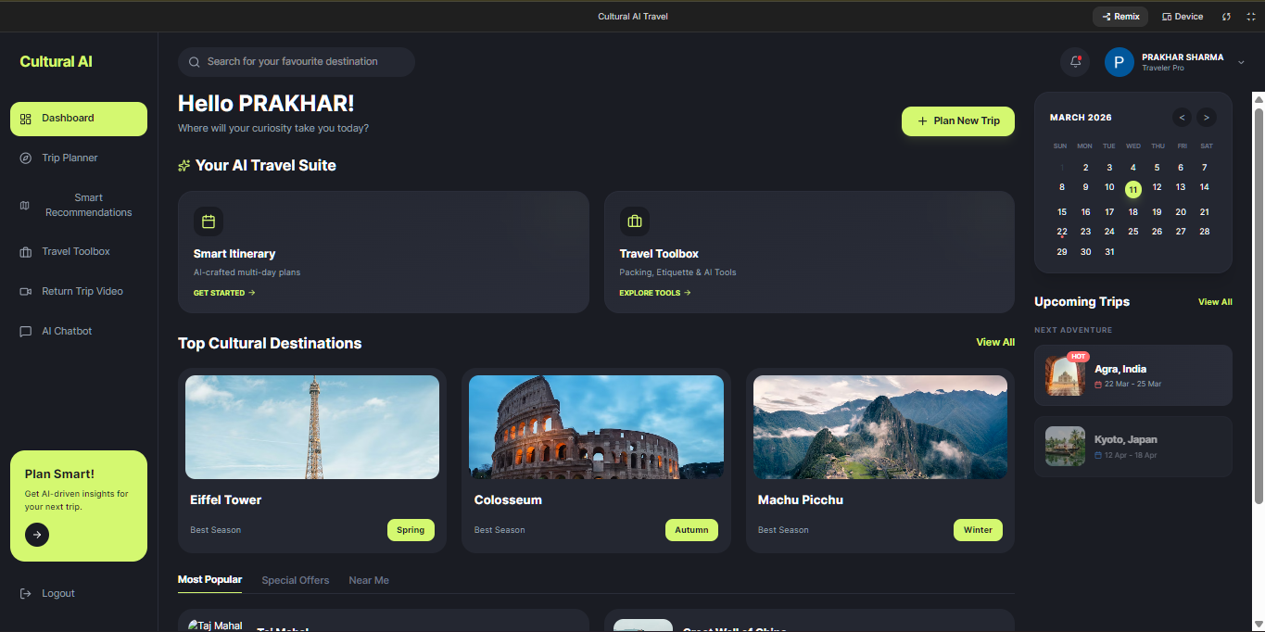

- Trip Planner:
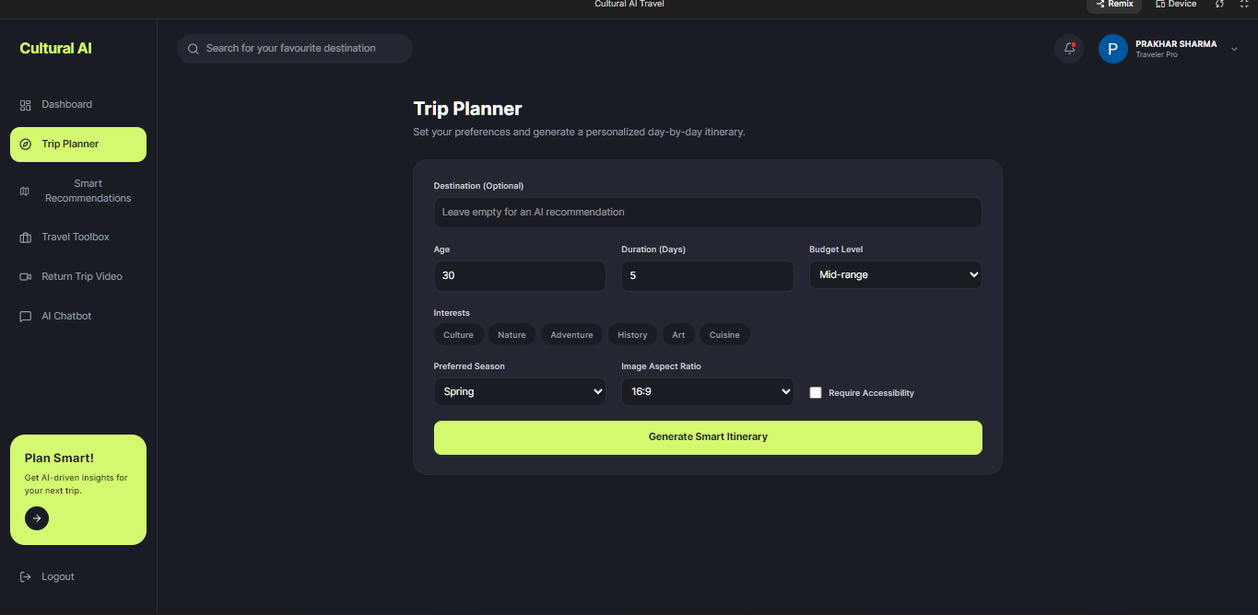

- Smart Recommendation:
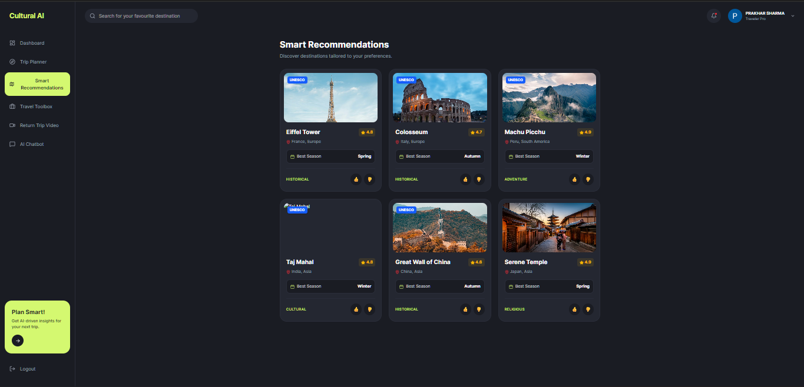
- Traveling Toolbox (Smart Innovative Feature):
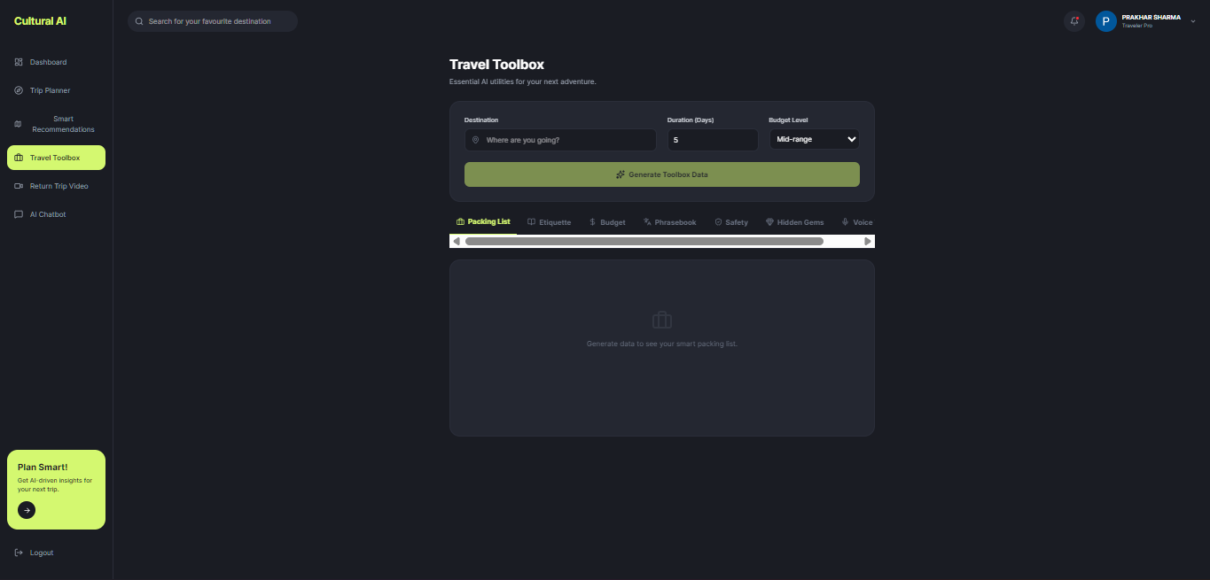
- Smart Chatbot(Aria):
